Huntsville Challenge Tournament
Saturday, April 8, 4SS, TC G/70, d5: See the website Events Calendar for more information.
Huntsville CHESS Club
North Alabama, Sunny Street Café, Madison, Sundays 4:30 – 9:00
If the student forces himself to examine all moves that smite, however absurd they may look at first glance, he is on the way to becoming a master of tactics. - Purdy
__________ HCC __________

New HCC Board of Directors
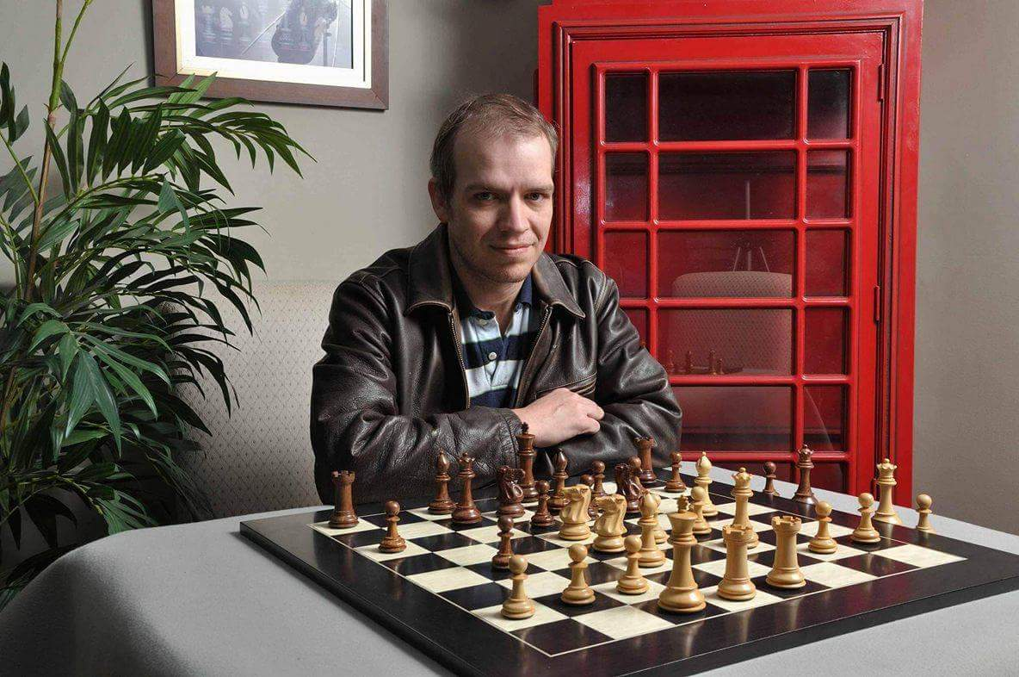
Josh McClellan – President
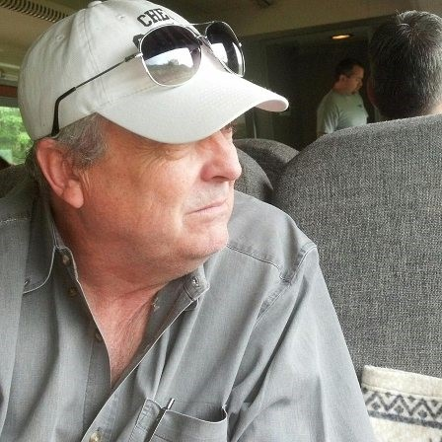
Don Maddox – Secretary
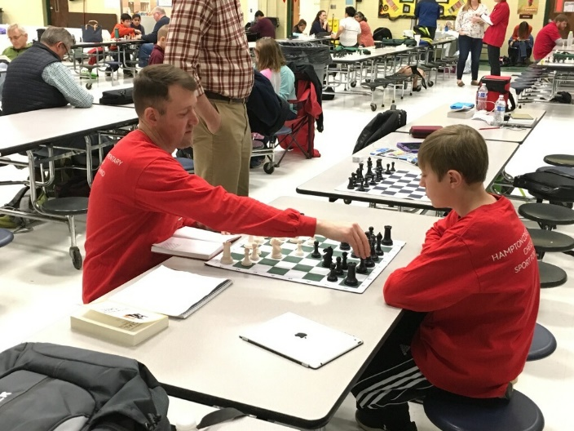
Patrick Dowd – Treasurer
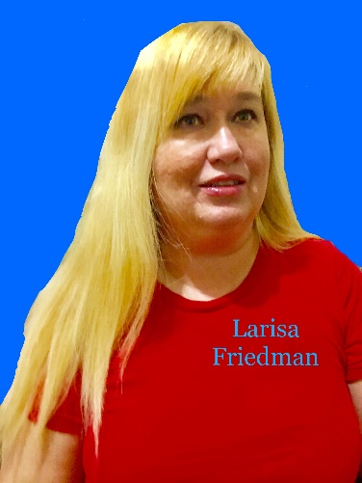
Larisa Friedman – Member at Large
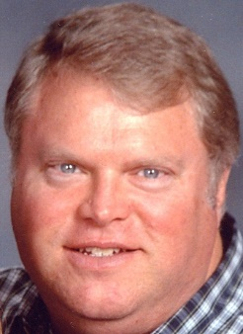
David Hayes – Member at Large
__________ HCC __________

Website: www.huntsvillecc.com

MeetUp: www.meetup.com/Huntsville-Chess-Club-Meetup/

FaceBook: www.facebook.com/huntsvillecc

InstaGram: www.instagram.com/huntsvillechessclub/?ref=badge

Twitter: twitter.com/huntsvillechess
Sponsors
Sunny Street Café – host of our weekly meetings. www.sunnystreetcafe.com
House of Staunton – donor of prizes and club chess sets. www.houseofstaunton.com

